 

**ST NICHOLAS CE PRIMARY SCHOOL**

School Road, Hurst, Berkshire RG10 0DR

**NEWSLETTER 02 – 23rd September 2022**

**St Nicholas School Vision Statement**

*Delivering a firm foundation for our children’s future success by celebrating individual  
and community achievement,  
built on Christian values.*

**ST NICHOLAS HURST - CHURCH SERVICES**[www.thru-christ.org.uk](http://www.thru-christ.org.uk)[www.achurchnearyou.com/stnicholashurst](http://www.achurchnearyou.com/stnicholashurst)

Sunday 25th Sept 11am Messy Church

Sunday 2nd October 11am Holy Communion

Sunday 16th October 11am Holy Communion

**

***Meet The Teacher! - Class information Evening***

*At the beginning of each academic year, we welcome parents in to school to meet their teachers and to find out more about their new classes. We invite you to join your class teacher on* ***Tuesday 27th September*** *at either of two sessions on offer. The presentations will be shared with parents who are unable to attend. If you have any questions, please speak to your class teacher.*

***Session 1 - 4.00pm Session 2 - 5.00pm***

**Harvest Festival**

**Tuesday 4th October 10.00am**

**We are collecting food for our children’s chosen charity,**

**The Link Visiting Scheme**

**Please bring in non-perishable items which will be parcelled up and delivered to those in need.**

We will be walking to church.

If you are able to join us and help ensure that the children are safe, please email

[admin@st-nicholas.wokingham.sch.uk](mailto:admin@st-nicholas.wokingham.sch.uk)

Thank you

**EVENTS CALENDAR**

**September**

Tue 27th **Class Information Evenings, 4pm or 5pm**

**October**

Tue 4th **Harvest Festival at St Nicholas Church**

Wed 5th Owl and Falconry Visit (KS1)

Fri 7th Longfellow Trip - Baylab Science Visit

Wed 19th Open Morning for prospective EYFS parents

Thu 20th Flu Vaccination (nasal spray) - *All pupils*

**Fri 21st INSET DAY – School Closed**

**24th-28th HALF TERM – School Closed**

**November**

Wed 2nd TS Eliot/Longfellow Trip - The Living Rainforest

Thu 3rd Open Morning for prospective EYFS parents

Mon 7th Alter Ego Drama Performance KS2

Tue 8th Parents Evening, 3.30pm-6pm

Wed 9th Parents Evening, 3.30pm-6pm

Fri 11th Individual & Sibling Portrait Photos

**December**

Tue 6th St Nicholas Day Service, 10am Church

Wed 7th EYFS and KS1 Nativity

Thu 8th EYFS and KS1 Nativity

Fri 9th Christmas Jumper Day

Fri 9th Open Morning for prospective EYFS parents

Mon 19th Christmas Craft Day

Tue 20th Carol Service, 10am St Nicholas Church

Tue 20th Last Day of Term, 1:30pm

Dear Parents and Carers

**Attendance**

St Nicholas School believes that punctual and regular school attendance is essential for effective learning.

We are committed to ensuring that all students attend school regularly and have an attendance of above 97% for the academic year. Regular school attendance is vital if students are to benefit from the experiences, which the school offers them; we believe that students should attend school regularly because this is where they learn and this is where they grow.

Our vision states that we are building firm foundations for our children. Poor attendance this increasingly challenging and therefore the foundations are compromised and children and teachers have to work even harder to make up missed time.

Our teachers are ready to start their first lesson at 9.00am, and our teaching assistants are already listening to readers and working with small groups from 8.35am.

**Why is attendance so important?**

It is difficult to “catch up” when time is missed. Even starting the day late can impact your child’s entire day and effects learning in the classroom.

Your child will feel connected academically and socially when they have good attendance

Good school attendance helps to build habits that last a lifetime and transfer beyond school



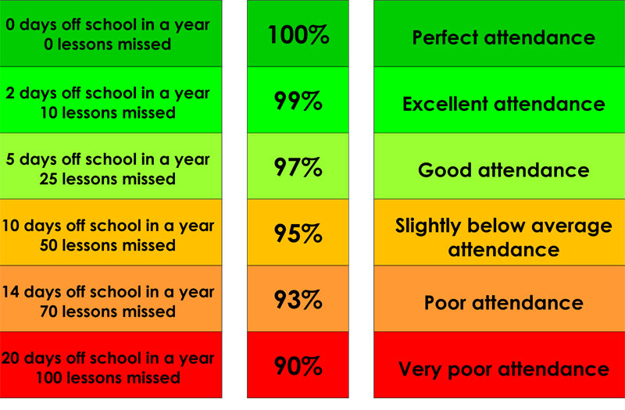

PTA Thanks

I would like to take a moment to thank those on the PTA who have worked tirelessly over the past years. Not only do our children enjoy the events held but the children benefit from the funds raised which are used to fund the extra resources for school. We are currently fundraising for an outside canopy for EYFS, improved outside play areas and equipment and, longer term, an outside classroom.

The PTA need more parents to help organise and run these events. You can help by contacting your class rep or joining their Facebook group here <https://www.facebook.com/groups/1763798920544307>

There are lots of planned events upcoming, however, these can only go ahead with parental support.

Miss Wheeler and Mrs Thomas are currently our staff PTA representatives.

Sarah Hilling, Head of School

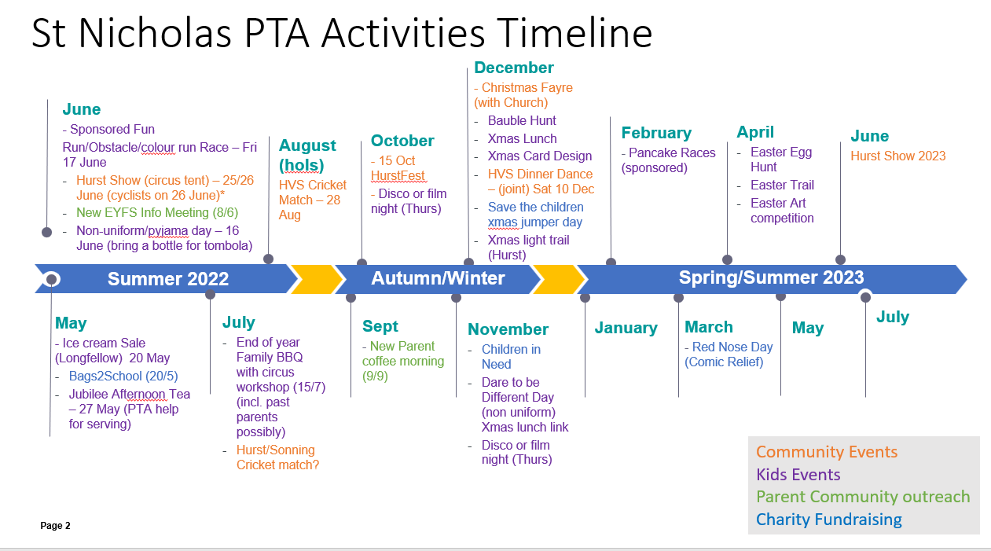

**School Clubs and Activities**

|  |  |  |
| --- | --- | --- |
| **Day** | **What’s On?** | **For more info/ booking** |
| **Monday** | **8.00am Judo with Ollie Fricker**  **1.00pm Guitar Tuition with Tony Lyons**  **7.00pm Adult Yoga** | [**https://judo-school.class4kids.co.uk/term/33**](https://judo-school.class4kids.co.uk/term/33)  [**tonytonylyons@gmail.com**](mailto:tonytonylyons@gmail.com)  Katy Meads on 07761591605 |
| **Tuesday** | **1.00pm Berkshire Maestros Tuition**  **4.00pm Netball Club – Mrs Rudd Get Active** | [**www.berkshiremaestros.org.uk**](http://www.berkshiremaestros.org.uk)  book through Get Active below |
| **Wednesday** |  |  |
| **Thursday** | ***Lunchtime Zumba for all – coming soon!*** |  |
| **Friday** | **12.00pm Recorder Club**  ***1.00pm – Group Piano tuition – Coming soon!*** | [**admin@st-nicholas.wokingham.sch.uk**](mailto:admin@st-nicholas.wokingham.sch.uk)  <https://www.wekey.co.uk/schools> |
| **Everyday** | **Get Active After School Club** [**https://getactivesportsuk.coordinate.cloud/project/30962**](https://getactivesportsuk.coordinate.cloud/project/30962) | |

**School Lunch**

Thank you for the feedback regarding the new catering team. Your emails have been forwarded on to the team. If you have any questions regarding school lunches, please contact the provider via this link: <https://caterlinkltd.co.uk/contact/>

**PE Days Schedule**

Please see below the allocated PE days for each class. Please ensure your child comes to school wearing appropriate PE uniform on these days:

|  |  |  |  |  |
| --- | --- | --- | --- | --- |
| **MILNE** | **DONALDSON** | **TS ELIOT** | **LONGFELLOW** | **BLAKE** |
| Tuesday  Thursday | Tuesday  Thursday | Monday  Wednesday | Monday  Wednesday | Monday  Friday |

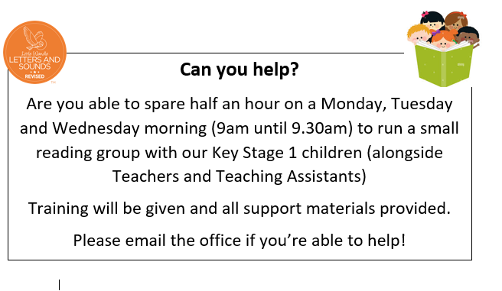

**Twyford Together Charity 5K and Fun Run**

Just two weeks to go until the *Twyford Together Charity 5K and Fun Run*on Sunday 9 October at The Piggott School. It's the tenth anniversary of the event this year and promises to be extra special. There are races for all ages (including a chip-timed, 5K so the children have an opportunity to cheer you on!), fastest street competition and ... new for '22: fastest business/club/society. To register, visit the Twyford Together website at [www.twyfordtogether.org](https://twyfordtogether.org/upcoming-events/twyfordtogether-charity-5k-and-fun-run/).



[**Oktoberfest Hurst Beer & Music festival - 15.10.22**](https://www.facebook.com/groups/2442931366059816)

**This event is kindly sponsored by**[**VP Estate Agents Twyford**](http://www.villageproperties.org)**and**[**The Money Guardian**](http://www.themoneyguardian.co.uk)

**Live music from ‘The Originals’ & ‘The Riots’**

**Live DJ by Thames Valley Discos**

**Local beers & Ales, prosecco, gin and Jagermeister bar!  
  
Ticket price - £19.50 (plus £0.50 booking fee) -  Hog Roast & trimmings included in ticket price**

**Hurst Village Hall - Doors open 6.00pm**

**GET ACTIVE AFTER SCHOOL CLUB**

To book places from 6th September please visit

[**https://getactivesportsuk.coordinate.cloud/project/30962**](https://getactivesportsuk.coordinate.cloud/project/30962)



