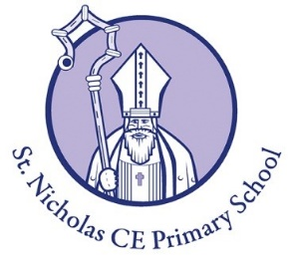
Curriculum Statement for
Modern Foreign Languages (MFL)
at St. Nicholas CofE Primary School, Hurst

"If you talk to a man in a language he understands, that goes to his head. If you talk to him in his language, that goes to his heart.”
Nelson Mandela

 |  | 
Community | Courageous Advocacy | Curiosity

Intent
St Nicholas Primary school’s aim is that all pupils will develop a genuine interest and positive curiosity about foreign languages, predominantly Spanish. Learning an additional language will offer pupils the opportunity to explore relationships between language and identity, develop a deeper understanding of other cultures and communities and the world around them alongside a better awareness of self, key individuals and cultural differences. The intention is that pupils will be enabled and encouraged to continue studying languages (Spanish is taught at all St Nicholas Primary School’s feeder secondary schools) beyond Key Stage 2 and ultimately be working towards becoming life-long language learners.

Implementation
St Nicholas Primary School uses the ‘Language Angels’ programme to offer a relevant, broad and vibrant curriculum to inspire and excite our pupils using a wide variety of topics and themes. The programme progressively develops pupils’ skills in Spanish through regularly taught and well-planned lessons. ‘Incidental’ Spanish is taught in between time-tabled lessons as part of classroom routines e.g., register taking. Children will progressively acquire, use and apply a growing bank of vocabulary, language skills and grammatical knowledge organised around age-appropriate topics and themes. In turn, these skills and knowledge will weave together to develop fluent and authentic language proficiency.

Intended Impact
The ‘Language Angels’ units increase in level of challenge, linguistic and grammatical complexity as the years progress. By the time pupils reach Progressive units (year 5 and 6) they will be exposed to longer texts and will be encouraged to formulate their own, more personalised responses based on a much wider bank of vocabulary, linguistic structures and grammatical knowledge. They will be able to create longer pieces of spoken and written language and are encouraged to use a variety of conjunctions, adverbs, adjectives, opinions and justifications.

Assessment
Assessments of the children’s knowledge, understanding and skills will be ongoing throughout the year. Assessment will include observations, discussions or recordings. A summative assessment of whether a child is working at age related expectations plus their attitude to learning of Spanish will be reported to parents/carers in a written annual report.

