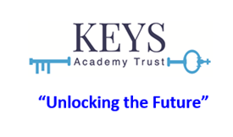
Relationships, Sex Education and Physical Health and Mental Well-Being Policy
Policy Level and Description: | 2 | TKAT Statutory Policy Guidance  SCHOOL POLICIES WILL INCLUDE CERTAIN CORE TEXT WITH SCHOOL-SPECIFIC ADDITIONS  ALL Schools require a policy on this topic/area. All local governing bodies will follow and have due regard to this model when drafting their local policy.
Reviewed by:  (Trust Officer) | Hester Wooller  CEO | Reviewed by:  (School representative) | Philip Theobald  Headteacher
Approved by:  (Trust Committee/Trust Board) | CECE | Approved by:  (LGB/LGB Committee) | LGB
Trust approval date:  (dd/mm/yyyy) | 06/03/2026 | LGB/LGB Committee  approval date:  (dd/mm/yyyy) | 18.06.26
Review due:  (mm/yyyy) | 10/2026

Contents
1. Introduction 2
2. Aims 3
3. Statutory requirements 3
4. Policy development 4
5. Definition 4
6. Curriculum 5
7. Delivery of RSE 6
7.1 Inclusivity 7
7.2 Use of Resources 8
8. Roles and responsibilities 8
9. Parents’ right to withdraw 10
10. Training 11
11. Monitoring arrangements 11

We are a family of distinctive schools at the heart of the diverse communities we serve. In line with our Christian ethos, we aspire to excellent learning and pastoral care for pupils and staff and are committed to being open and welcoming to all.

1. Introduction
The Keys Academy Trust (TKAT) believes that in order to create a happy and successful adult life, children need to have the self confidence to make informed decisions about their wellbeing, health and relationships. Relationships and sex education (RSE) is about giving children the information they need to help them develop healthy, nurturing relationships of all kinds, not just intimate relationships. Health education is giving pupils information to make well-informed, positive choices about their own health and wellbeing. TKAT recognises that physical health and mental wellbeing are interlinked, and it is important that pupils understand that good physical health contributes to good mental wellbeing, and vice versa.
TKAT has a responsibility under the Equality Act 2010 to ensure the best for all pupils at its schools irrespective of disability, educational needs, race, nationality, ethnic or national origin, sex, gender identity, pregnancy, maternity, religion or sexual orientation. As a result, RSE will be sensitive to the different needs of individual pupils and may need to adapt and change over time to reflect the needs of the particular cohort. TKAT schools may also take positive action, where it can be shown that it is proportionate, to deal with particular disadvantages affecting one group because of a protected characteristic.
All teaching will be sensitive and age appropriate in approach and content. At the point at which the Trust considers it appropriate to teach pupils about lesbian, gay, bisexual and transgender (LGBT), TKAT schools will ensure that this content is fully integrated into programmes of study for this area of the curriculum rather than delivered as a stand-alone unit or lesson.
TKAT is aware of the need to be mindful of, and respectful to a wide variety of faith and cultural beliefs within its schools which will make every attempt to be appropriately sensitive. Equally, it is essential that children still have access to the learning they need to stay safe, healthy, and understand their rights as individuals. TKAT believes that its pupils deserve the right to honest, clear, impartial scientific and factual information to help better form their own beliefs and values, free from bias, judgement, or subjective personal beliefs of those who teach them.

2. Aims
Through the delivery of high quality, evidence-based and age-appropriate RSE, the Trust aims to help prepare pupils for the onset of puberty, give them an understanding of sexual development and the importance of health and hygiene, create a positive culture in relation to sexuality and relationships and to ensure pupils know how and when to ask for help and where to access support. By the end of their education TKAT hopes pupils will have developed resilience and feelings of self-respect, confidence and empathy in preparation for the responsibilities and experiences of adult life.
Relationships education, RSE and health education are intended to help pupils to:
- Build healthy, respectful relationships focusing on family and friends.
- Understand how to be healthy and be aware of potential risk areas (such as drugs and alcohol).
- Learn about relationships and sex.
- Learn about mental wellbeing.
- Develop key personal attributes, such as kindness, integrity, generosity and honesty.
The RSE curriculum will be implemented in a sensitive way, in accordance with the Christian values of TKAT, taking into account the diverse backgrounds of the communities we serve.

3. Statutory requirements
TKAT primary schools, must provide relationships education to all pupils under section 34 of the Children and Social Work Act 2017.This would include the elements of sex education contained in the science curriculum.
In teaching RSE, we are required by our funding agreements to have regard to guidance issued by the secretary of state, as outlined in section 403 of the Education Act 1996.
We also have regard to legal duties set out in:
- Sections 406 and 407 of the Education Act 1996
- Part 6, chapter 1 of the Equality Act 2010
- The Public Sector Equality Duty (as set out in section 149 of the Equality Act 2010). This duty requires public bodies to have due regard to the need to eliminate discrimination, advance equality of opportunity and foster good relations between different people when carrying out their activities
At TKAT schools we teach RSE as set out in this policy.

4. Policy development
TKAT schools will consult parents and stakeholders when developing and reviewing this RSE policy.
This policy has been developed in consultation with staff, pupils and parents and then agreed by Trustees.
TKAT has agreed the definition and aims, and will review them annually while individual schools will
review and revise the other elements of the policy annually.

This policy should be read alongside the following TKAT policies: Child Protection and Safeguarding, Online Safety, SEND, PSHE, RE, Science.
The policy was developed in line with the Relationships Education, Relationships and Sex Education (RSE) and Health Education Statutory guidance for governing bodies, proprietors, head teachers, principals, senior leadership teams, teachers DfE July 2019 and the Church of England Policy Template for RSE, November 2019.
https://www.gov.uk/government/publications/relationships-education-relationships-and-sex-education-rse-and-health-education
https://www.churchofengland.org/more/education-and-schools/church-schools-and-academies/relationships-sex-and-health-education

5. Definition of relationships and sex education (RSE)
Relationship Education concerns the development of pupils’ understanding and ability to have positive, healthy, meaningful and sustained relationships of all kinds. It concerns the emotional, social and cultural development of pupils, and includes healthy living, personal identity, the importance of being in relationships with others, healthy relationships and staying safe, and respecting others.
Primary schools in TKAT may also choose to teach Sex Education, although this is not a statutory requirement for primary schools. Sex education concerns the development of pupils’ understanding of sex, sexual health and human sexuality.
All RSE involves a combination of sharing information, and exploring issues and values.
RSE will always be taught in an age appropriate manner, and will be taught in ways which recognise the cultural and religious backgrounds of all those in the school community.

6. Curriculum
Our curriculum is set out as per Appendix 3 but we may need to adapt/amend curriculum content to respond to the context and issues affecting pupils in an age-appropriate manner. Our school will inform parents of any significant changes to curriculum content.
We have developed the curriculum in consultation with parents, pupils and staff, taking into account the needs and feelings of pupils. If pupils ask questions outside the scope of our curriculum, teachers will respond in an appropriate manner so pupils are fully informed and don’t seek answers online. If appropriate, staff will inform parents if particular questions are raised by a child for them to discuss at home.
For more information about our curriculum, see our curriculum map in Appendix 3.

7. Delivery of RSE
RSE is taught within the personal, social, health and economic (PSHE) education curriculum. Biological aspects of RSE are taught within the science curriculum. Lessons will typically be delivered by the class teacher; however, health professionals may be used to support the delivery of teaching if available. Each school will ensure the delivery and content will be made accessible to all pupils, including those with special educational needs.
Across all Key Stages, pupils will be supported with developing the following skills:
- Communication, including how to manage changing relationships and emotions
- Recognising and assessing potential risks
- Assertiveness
- Seeking help and support when required
- Informed decision-making
- Self-respect and empathy for others
- Recognising and maximising a healthy lifestyle
- Managing conflict
- Discussion and group work
These skills are taught within the context of family life, taking care to make sure that there is no stigmatisation of children based on their home circumstances. See Appendix 2 for an overview of curriculum content taught.
Pupils in Year 5 and Year 6 also receive stand-alone sex education sessions. Please see Appendix 3 for information about what is covered. Parents have the right to withdraw their child from these sessions. Information will be provided to parents regarding the curriculum content of these sessions. If a parent is considering withdrawing their child from these sessions, we encourage them to speak to the Headteacher.

7.1 Inclusivity
We will teach about these topics in a manner that:
- Considers how a diverse range of pupils will relate to them
- Is sensitive to all pupils’ experiences
- During lessons, makes pupils feel:
  - Safe and supported
  - Able to engage with the key messages
We will also:
- Make sure that pupils learn about these topics in an environment that’s appropriate for them, for example in:
  - A whole-class setting
  - Small groups or targeted sessions
  - 1-to-1 discussions
  - Digital formats
- Give careful consideration to the level of differentiation needed

Pupils with special educational needs and/or disabilities
The Trust will endeavour to ensure that RSE, relationships education and health education is accessible for all pupils. We are aware that some pupils are more vulnerable to exploitation, bullying and other issues due to the nature of their SEND and RSE, relationships education and health education may be particularly important for such pupils, for example those with social, emotional and mental health needs or learning disabilities. Teaching will be sensitive, age-appropriate, developmentally appropriate, differentiated and personalised to meet the specific needs of pupils at different developmental stages.
Staff will make reasonable adjustments to alleviate disadvantages faced by pupils with disabilities and will be mindful of the SEND Code of Practice and the Trust’s SEND policy when planning for these subjects.

7.2 Use of Resources
We will consider whether any resources we plan to use:
- Are aligned with the teaching requirements set out in the statutory RSE guidance
- Would support pupils in applying their knowledge in different contexts and settings
- Are age-appropriate, given the age, developmental stage and background of our pupils
- Are evidence-based and contain robust facts and statistics
- Fit into our curriculum plan
- Are from credible sources
- Are compatible with effective teaching approaches
- Are sensitive to pupils’ experiences and won’t provoke distress

8. Roles and responsibilities
8.1 The governing board
TKAT Board of Trustees will review and approve the Definition and Aims of RSE across the Trust. The Local Governing Body will review the remainder of the policy and approve the RSE policy for their school, and hold the headteacher/head of school to account for its implementation.

8.2 The Headteacher/Head of School
The headteacher/head of school is responsible for ensuring that RSE is taught consistently across the school, and for managing requests to withdraw pupils from non-statutory components of RSE (see section 8).
The headteacher/head of school will ensure that staff are supported, receive regular professional development training in how to deliver RSE and are up to date with policy changes. They will ensure that RSE is well led, effectively managed and well planned across various subjects (to avoid unnecessary duplication of topics) and that the quality of provision is subject to regular and effective self-evaluation. The headteacher/head of school will ensure that teaching is age-appropriate, delivered in ways that are accessible to all pupils with SEND, and that the subjects are resourced, staffed and timetabled appropriately. They will ensure that teaching delivered by any external organisation is age-appropriate and accessible for pupils and will liaise with parents about any concerns or opinions regarding RSE, relationships and health education provision.

8.3 Staff
Staff are responsible for:
- Delivering RSE in a sensitive way
- Modelling positive attitudes to RSE
- Monitoring progress
- Responding to the needs of individual pupils, including those with SEND
- Responding appropriately to pupils whose parents wish them to be withdrawn from the non-statutory components of RSE
- Staff do not have the right to opt out of teaching RSE. Staff who have concerns about teaching RSE are encouraged to discuss this with the headteacher.

8.4 Pupils
Pupils are expected to engage fully in RSE and, when discussing issues related to RSE, treat others with respect and sensitivity.

9. Parents’ right to withdraw
TKAT hopes that parents will feel comfortable with, and understand the importance of, the education provided to their children as described in this policy.
Parents only have the right to withdraw their children from the non-statutory components of RSE. All other aspects of the RSE curriculum are statutory and part of the national curriculum.
Requests for withdrawal should be put in writing and addressed to the headteacher/head of school. A copy of withdrawal requests will be placed in the pupil’s educational record. The headteacher will discuss the request with parents and take appropriate action.
If the decision to withdraw is made, alternative work will be given to pupils who are withdrawn from RSE.

10. Training
Staff are trained on the delivery of RSE as part of their induction and it is included in our continuing professional development calendar.
The headteacher/head of school will also invite visitors from outside the school, such as school nurses to provide support and training to staff teaching RSE.

11. Monitoring arrangements
The delivery of RSE is monitored by the subject leader and headteacher/head of school in a variety of ways. These may include:
- Learning walks
- Planning monitoring
- Pupil conferencing
- Book monitoring
Pupils’ development in RSE is monitored by class teachers as part of our internal assessment systems.
This policy will be reviewed by TKAT annually. Following review, the policy will be approved by the Local Governing Body.

APPENDIX 1- DfE Guidance for Parents and Carers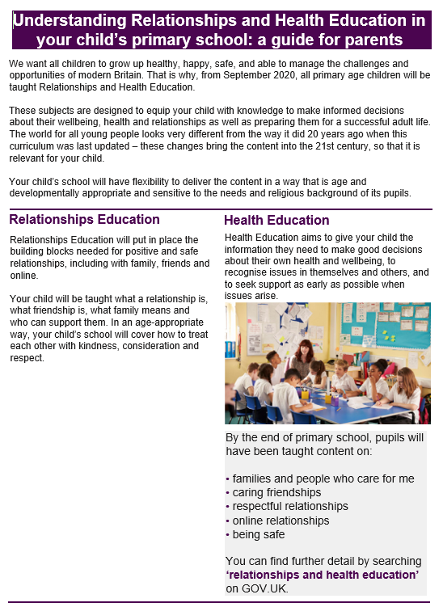
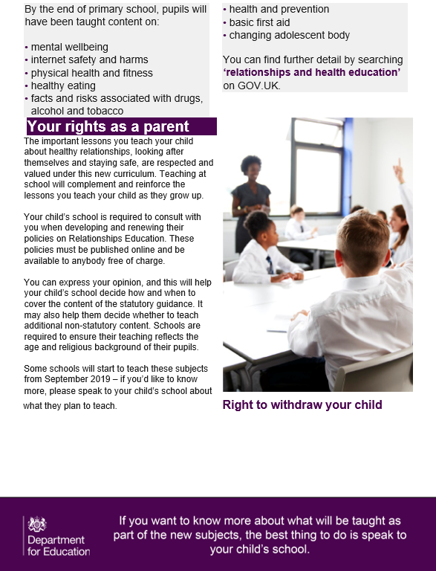

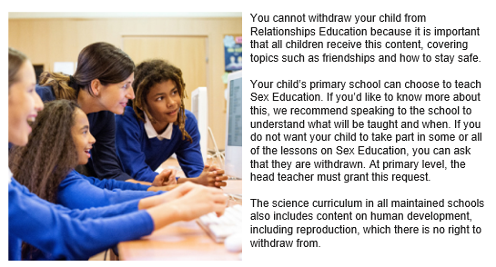

Appendix 2: Curriculum Overview

By the end of primary school children will learn about:

Families and people who care for me | Pupils should know  - that families are important for children growing up because they can give love, security and stability.  - the characteristics of healthy family life, commitment to each other, including in times of difficulty, protection and care for children and other family members, the importance of spending time together and sharing each other’s lives.  - that others’ families, either in school or in the wider world, sometimes look different from their family, but that they should respect everyone, however different their family may be, and know that other children’s families are also characterised by love and care.  - that stable, caring relationships, which may be of different types, are at the heart of happy families, and are important for children’s security as they grow up.  - that marriage represents a formal and legally recognised commitment of two people to each other which is intended to be lifelong.  - how to recognise if family relationships are making them feel unhappy or unsafe, and how to seek help or advice from others if needed.
Caring friendships | Pupils should know  - how important friendships are in making us feel happy and secure, and how people choose and make friends.  - the characteristics of friendships, including mutual respect, truthfulness, trustworthiness, loyalty, kindness, generosity, trust, sharing interests and experiences and support with problems and difficulties.  - that healthy friendships are positive and welcoming towards others, and do not make others feel lonely or excluded.  - that most friendships have ups and downs, and that these can often be worked through so that the friendship is repaired or even strengthened, and that resorting to violence is never right.  - how to recognise who to trust and who not to trust, how to judge when a friendship is making them feel unhappy or uncomfortable, managing conflict, how to manage these situations and how to seek help or advice from others, if needed.
Respectful relationships | Pupils should know  - the importance of respecting others, even when they are very different from them (for example, physically, in character, personality or backgrounds), or make different choices or have different preferences or beliefs.  - practical steps they can take in a range of different contexts to improve or support respectful relationships.  - the conventions of courtesy and manners.  - the importance of self-respect and how this links to their own happiness.  - that in school and in wider society they can expect to be treated with respect by others, and that in turn they should show due respect to others, including those in positions of authority.  - about different types of bullying (including cyberbullying), the impact of bullying, responsibilities of bystanders (primarily reporting bullying to an adult) and how to get help.  - what a stereotype is, and how stereotypes can be unfair, negative or destructive.  - the importance of permission-seeking and giving in relationships with friends, peers and adults.
Online relationships | Pupils should know  - that people sometimes behave differently online, including by pretending to be someone they are not.  - that the same principles apply to online relationships as to face-to-face relationships, including the importance of respect for others online including when we are anonymous.  - the rules and principles for keeping safe online, how to recognise risks, harmful content and contact, and how to report them.  - how to critically consider their online friendships and sources of information including awareness of the risks associated with people they have never met.  - how information and data is shared and used online.
Being safe | Pupils should know  - what sorts of boundaries are appropriate in friendships with peers and others (including in a digital context).  - about the concept of privacy and the implications of it for both children and adults; including that it is not always right to keep secrets if they relate to being safe.  - that each person’s body belongs to them, and the differences between appropriate and inappropriate or unsafe physical, and other, contact.  - how to respond safely and appropriately to adults they may encounter (in all contexts, including online) whom they do not know.  - how to recognise and report feelings of being unsafe or feeling bad about any adult.  - how to ask for advice or help for themselves or others, and to keep trying until they are heard.  - how to report concerns or abuse, and the vocabulary and confidence needed to do so.  - where to get advice e.g. family, school and/or other sources.
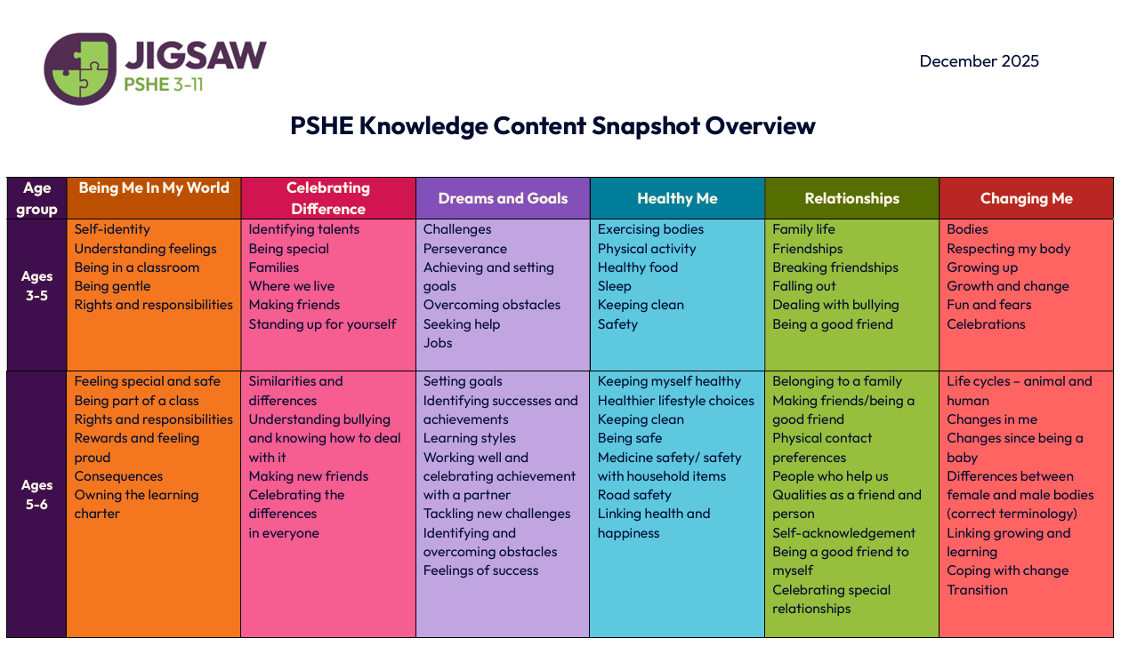

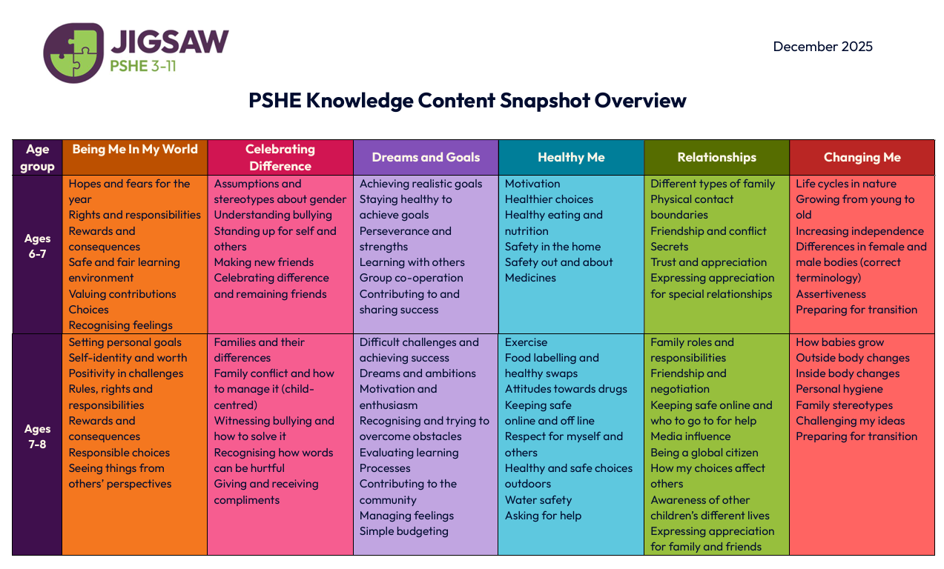

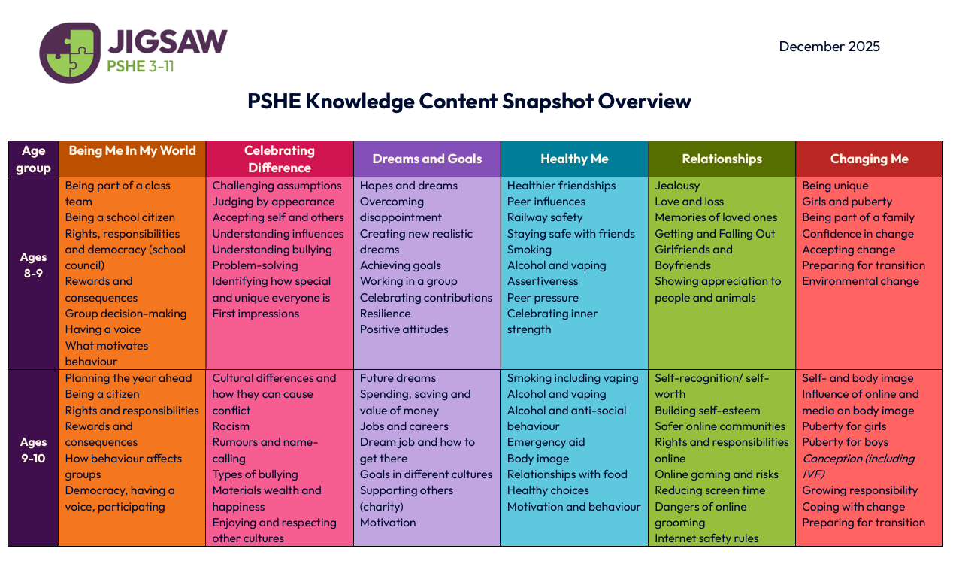
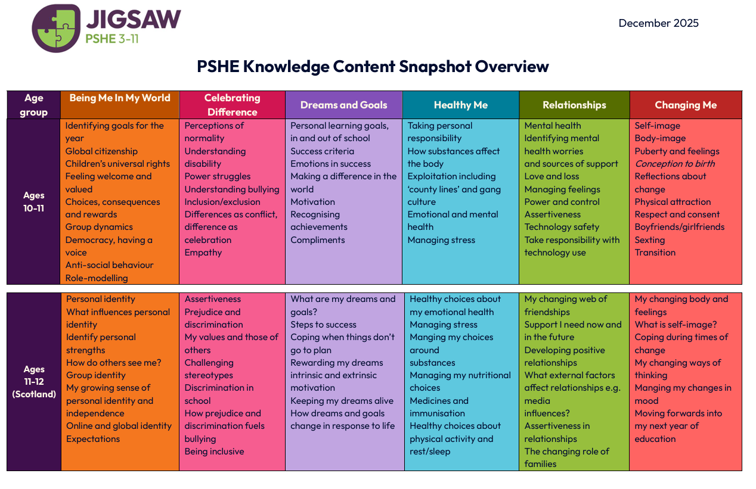

APPENDIX 3
Relationships Education curriculum map

Year group | Term | Topic/theme details | End of year/ key stage statements | Resources
Reception | Autumn 1  Autumn 2  Spring 1  Spring 2  Summer 1  Summer 2 | Being Me in My World: settling in, belonging, class rules, feelings and kindness.  Celebrating Difference: similarities, differences, friendship and respectful behaviour.  Dreams and Goals: aspirations, perseverance, working together and celebrating achievement.  Healthy Me: keeping healthy, safe choices, hygiene, exercise and medicines.  Relationships: families, friendships, people who help us and solving friendship problems.  Changing Me: growing up, body parts, change, life cycles and managing feelings about transition. | PSE  Self-confidence and self esteem  Making Relationships  Behaviour and Self Control  Sense of Community  Self-Care  Healthy and Bodily Awareness | Jigsaw PSHE EYFS materials; Jigsaw Friends; Jigsaw Charter; Calm Me scripts; story books, circle-time resources, feelings cards and class reflection activities.
Year 1 | Autumn 1  Autumn 2  Spring 1  Spring 2  Summer 1  Summer 2 | Being Me in My World: rights and responsibilities, class charter, feeling safe and making positive choices.  Celebrating Difference: similarities and differences, bullying, kindness and making new friends.  Dreams and Goals: setting simple goals, tackling challenges, working with a partner and celebrating success.  Healthy Me: healthy choices, hygiene, medicines, road safety and feeling safe.  Relationships: families, friends, people who help us and resolving friendship problems.  Changing Me: life cycles, body parts, growing from baby to adult and coping with change. | 1a, to recognise what they like and dislike, what is fair and unfair and what is right and wrong  1b, to share their opinions on things that matter to them and explain their views  1c, to recognise, name and deal with their feelings in a positive way  1d, to think about themselves, learn from their experiences and recognise what they are good at  2a, to take part in discussions with one other person and the whole class  2c, to recognise choices they can make and recognise the difference between right and wrong  2e, to realise that people and other living things have needs and that they have responsibilities to meet them  2f, that they belong to various groups and communities, such as family and school  3a to make simple choice that improve their health and well-being  3e, the names of the main parts of the body  4b, to listen to people and play and work cooperatively  4c, to recognise how their behaviour affects other people, to identify and respect the differences and similarities between people  4d that family and friends should care for each other | Jigsaw PSHE Year 1 materials; Jigsaw Friend; Jigsaw Charter; Calm Me scripts; lesson slides, story scenarios, circle-time activities and Jigsaw Journal tasks.
Year 2 | Autumn 1  Autumn 2  Spring 1  Spring 2  Summer 1  Summer 2 | Being Me in My World: hopes and fears, rights and responsibilities, rewards, consequences and learning together.  Celebrating Difference: assumptions, stereotypes, bullying, standing up for self and others, and celebrating uniqueness.  Dreams and Goals: realistic goals, perseverance, learning strengths, teamwork and celebrating progress.  Healthy Me: motivation, healthy food, relaxation, medicines, keeping safe and healthy choices.  Relationships: families, friendship, trust, physical contact, conflict and seeking help.  Changing Me: life cycles, growing from young to old, body changes, privacy and preparing for transition. | PSHE & Citizenship Framework  1b share their opinions on things that matter to them and explain their views  1d, to think about themselves, learn from their experiences and recognise what they are good at  2e, to realise that people and other living things have needs, and that they have responsibilities to meet them  3a, how to make simple choices that improve their health and well-being  3b, to maintain personal hygiene  3d, about the process of growing from young to old and how people’s needs change 4d that families and friends should care for each other  3e, the names of the main parts of the body  4c, to identify and respect the differences and similarities between people  National Curriculum Science  2a, to recognise and compare the main external parts of the bodies of humans and of other animals  Sc2/1b, that animals including humans move, feed, grow, use their senses, and reproduce | Jigsaw PSHE Year 2 materials; Jigsaw Friend; Jigsaw Charter; Calm Me scripts; lesson slides, story cards, discussion prompts, Jigsaw Journal tasks and age-appropriate picture resources.
Year 3 | Autumn 1  Autumn 2  Spring 1  Spring 2  Summer 1  Summer 2 | Being Me in My World: setting personal goals, self-worth, rules, rights, responsibilities and choices.  Celebrating Difference: families, differences, bullying, witnesses, problem-solving and celebrating difference.  Dreams and Goals: ambitions, challenges, perseverance, overcoming obstacles and evaluating learning.  Healthy Me: exercise, food, drugs, being safe, managing risk and making healthy choices.  Relationships: friendship, family roles, keeping safe, online relationships and being a global citizen.  Changing Me: babies, body changes, puberty introduction, outside and inside body changes, and transition. | PSHE & Citizenship Framework  1b, to recognise their worth as individuals by identifying positive things about themselves and their achievements, seeing their mistakes, making amends and setting personal goals PSHE & Citizenship Framework  1c, to face new challenges positively by collecting information, looking for help, making responsible choices and taking action  2f, to look after their money and realise that future wants and needs may be met through saving  3c, about how the body changes as they approach puberty  3e, to recognise the different risks in different situations and then decide how to behave responsibly, including sensible road use, and judging what kind of physical contact is acceptable or unacceptable  4a that their actions affect themselves and others, to care about other people’s feelings and to try to see things from their points of view 2k, to explore how the media present information  4c to be aware of different types of relationship, including marriage and those between friends and families  4e to recognise and challenge stereotypes,  National Curriculum Science  2a, to recognise and compare the main external parts of the bodies of humans and of other animals | Jigsaw PSHE Year 3 materials; Jigsaw Friend; Jigsaw Charter; Calm Me scripts; lesson slides, scenario cards, role-play resources, Jigsaw Journal tasks and age-appropriate body-change resources.
Year 4 | Autumn 1  Autumn 2  Spring 1  Spring 2  Summer 1  Summer 2 | Being Me in My World: class community, democracy, rights, responsibilities, rewards, consequences and school roles.  Celebrating Difference: assumptions, judgement, bullying, bystanders, problem-solving and accepting difference.  Dreams and Goals: hopes, dreams, resilience, group work, overcoming disappointment and celebrating contribution.  Healthy Me: friendship groups, peer pressure, smoking, alcohol, assertiveness and healthy choices.  Relationships: jealousy, love and loss, memories, getting on and falling out, and online relationships.  Changing Me: body changes, puberty, personal hygiene, feelings, reproduction in animals and managing transition. | PSHE & Citizenship Framework  1c, to face new challenges positively by collecting information, looking for help making responsible choices, and taking action  1d, to recognise as they approach puberty, how people’s emotions change at that time and how to deal with their feelings towards themselves, their families and others in a positive way  2f, to resolve differences by looking at alternatives, making decisions and explaining choices  4a, that their actions affect themselves and others, to care about other people’s feelings and to try to see things from their points of view  3c, learn about how the body changes as children approach puberty  3f, that pressure to behave in an unacceptable or risky way can come from a variety of sources, including people they know, and how to ask for help and use basic techniques for resisting pressure to do wrong  4g, where individuals, families and groups can get help and support  National Curriculum Science 1a, that the life processes common to humans and other animals include nutrition, movement, growth and reproduction 2f, about the main stages of the human life cycle | Jigsaw PSHE Year 4 materials; Jigsaw Friend; Jigsaw Charter; Calm Me scripts; lesson slides, discussion cards, role-play activities, Jigsaw Journal tasks and age-appropriate puberty resources.
Relationships and Sex Education curriculum map Year 5 and Year 6
Year 5 | Autumn 1  Autumn 2  Spring 1  Spring 2  Summer 1  Summer 2 | Being Me in My World: rights, responsibilities, democracy, participation, rewards and consequences.  Celebrating Difference: culture, racism, rumours, name-calling, bullying and celebrating difference.  Dreams and Goals: future dreams, jobs, money, motivation, supporting others and celebrating achievement.  Healthy Me: smoking, alcohol, emergency aid, body image, healthy lifestyle choices and managing pressure.  Relationships: self-recognition, online communities, online safety, relationships with technology and safer communication.  Changing Me: puberty, body changes, conception, growing responsibility, self-image and transition. Non-statutory sex education content taught sensitively with parental information shared in advance. | PSHE & Citizenship Framework  1a, To talk and write about their opinions, and explain their views on issues that affect themselves and society  1d, to recognise as they approach puberty, how people’s emotions change at that time and how to deal with their feelings towards themselves, their families and others in a positive way  2f, about the main stages of the human life cycle  2k, To explore how the media present information  3c, learn about how the body changes as children approach puberty  4e, To recognise and challenge stereotypes  4f, That differences and similarities between people arise from a number of factors, including cultural, ethnic, racial and religious diversity gender and disability  4a, That their actions affect themselves and others, to care about other peoples feeling and to try to see things from their points of view  4c To be aware of different types of relationship, including marriage and those between friends and families, and to develop the skills to be effective in relationships  National Curriculum Science 1a, that the life processes common to humans and other animals include nutrition, movement, growth and reproduction 2f, about the main stages of the human life cycle  SEX Education  Pupils learn that puberty is a natural process and can describe key physical and emotional changes for girls and boys, including menstruation, erections, ejaculation, wet dreams, body hair, voice changes and growth spurts. They learn that sexual intercourse can lead to conception and understand, in age-appropriate terms, how sperm and egg meet, fertilisation occurs and pregnancy begins. Pupils are introduced to the idea that some people may need support to have a baby, such as fertility treatment/IVF, and they learn that trusted adults can help them with questions or worries about puberty, relationships and growing up. This non-statutory content is taught sensitively through the Jigsaw PSHE Changing Me unit, with parental information shared in advance. | Jigsaw PSHE Year 5 materials; Jigsaw Friend; Jigsaw Charter; Calm Me scripts; lesson slides, scenario cards, online safety resources, Jigsaw Journal tasks and age-appropriate puberty/sex education resources.
Year 6 | Autumn 1  Autumn 2  Spring 1  Spring 2  Summer 1  Summer 2 | Being Me in My World: personal goals, global citizenship, rights, responsibilities, rewards, consequences and learning charter.  Celebrating Difference: perceptions of normality, power struggles, bullying, difference, inclusion and respect.  Dreams and Goals: personal learning goals, success criteria, motivation, recognising achievements and preparing for the future.  Healthy Me: taking responsibility for physical and emotional health, drugs, exploitation, gangs, emotional wellbeing and healthy choices.  Relationships: mental health, love and loss, managing feelings, online safety, technology and support networks.  Changing Me: puberty, body image, conception and birth, relationships, respect, transition to secondary school and non-statutory sex education taught sensitively with parental information shared in advance. | PSHE & Citizenship Framework  1c, To face new challenges positively by collecting information, looking for help, making responsible choices, and taking action  1d, to recognise as they approach puberty, how people’s emotions change at that time and how to deal with their feelings towards themselves, their families and others in a positive way  2e, That their actions affect themselves and others, to care about other people’s feelings and to try to see things from their points of view  3b that bacteria and viruses can affect health and that following simple, safe routines can reduce their spread  3c, learn about how the body changes as children approach puberty  4a That their actions affect themselves and others, to care about other people’s feelings and to try to see things from their points of view  4c, To be aware of different types of relations, including marriage and those between friends and families, and to develop the skills to be effective in relationships  4g Where individuals, families and groups can get help and support  National Curriculum Science 1a, that the life processes common to humans and other animals include nutrition, movement, growth and reproduction  SEX Education  Pupils revisit and extend prior learning about puberty, including the physical and emotional changes experienced by girls and boys and the importance of looking after themselves physically and emotionally. They learn, in age-appropriate terms, how a baby develops from conception through the nine months of pregnancy and how babies are born, including key scientific vocabulary such as uterus/womb, egg/ovum, sperm, fertilisation, embryo, foetus, placenta, umbilical cord, labour and birth. Pupils consider how physical attraction can change the nature of a relationship, the importance of mutual respect, consent, assertiveness and not feeling pressured into anything they do not want to do. They also explore self-image, body image, self-esteem and strategies for preparing emotionally for transition to secondary school. This non-statutory content is taught sensitively through the Jigsaw PSHE Changing Me unit, with parental information shared in advance. | Jigsaw PSHE Year 6 materials; Jigsaw Friend; Jigsaw Charter; Calm Me scripts; lesson slides, scenario cards, online safety resources, transition activities, Jigsaw Journal tasks and age-appropriate puberty/sex education resources.

Marriage in England and Wales is available to both opposite sex and same sex couples. The Marriage (Same Sex Couples) Act 2013 extended marriage to same sex couples in England and Wales. The ceremony through which a couple get married may be civil or religious. The legal age of marriage in England is now 18 years.

