

St Nicholas CE Primary School

‘Laying firm foundations to believe and achieve.’



Anti-bullying Policy

Date: | Spring 2025
Review: | Spring 2026
 | Spring 2028

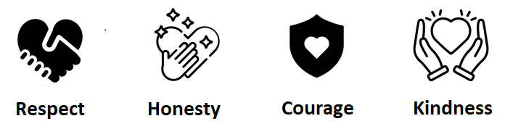

St Nicholas CE Primary School is committed to developing an anti-bullying culture where the bullying of adults, children or young people is not tolerated in any form. This policy is a reflection of the school’s vision and values. As we endeavour to lay firm foundations, unlocking future potential for every member of our community, the effective prevention and tackling of bullying in our school helps to create a safe and disciplined environment. By creating a culture where our school values of love and respect are so highly prized, pupils can learn and fulfil their potential, free from bullying and discrimination. We also seek to learn from good anti-bullying practice elsewhere and utilise support from The Keys Academy Trust, Oxford Diocese, our local authority and other relevant organisations when appropriate. This policy is based on guidance, best practice, research and law.

St Nicholas CE Primary School’s vision is to lay firm foundations to believe and achieve. We recognise that all forms of bullying, especially if left unaddressed, can have a damaging effect on individuals, thus weakening those foundations. By effectively preventing and tackling bullying, our school can help to create a safe and disciplined environment, where pupils are able to learn, fulfil their potential and go on to live life in all its fullness.

Bullying in any form will not be tolerated at our school. This policy outlines what we will do to prevent and address all forms of bullying, and will provide staff, governors and parents with clear guidance on the principles and practices that help support the behaviour policy, as well as investigate and act upon any bullying concerns. This includes the following:

- All governors, teaching and non-teaching staff, students and parents should have an understanding of what bullying is, what the school’s policy is on bullying and follow it when bullying is reported.
- All pupils and parents should know what they should do if bullying arises.
- The school will ensure the policy has been discussed with and agreed by a range of stakeholders.

As a school, we take bullying seriously. Pupils and parents should be assured that they will be supported when bullying is reported and that will be fully investigated. This does not, however, mean that every allegation of bullying will be upheld.

This policy is based on DfE guidance Preventing and Tackling Bullying, updated in July 2017 and supporting documents. It also considers the DfE statutory guidance include Keeping Children Safe in Education and Sexual violence and sexual harassment between children in schools and colleges guidance. The School has also explored DfE guidance and Children’s Cyberbullying: Understand, Prevent and Respond: Guidance for Schools in the development of this policy.

This policy should be read in conjunction with the Behaviour Policy.

Definition

- Bullying can be defined as “behaviour by an individual or a group, repeated over time that intentionally hurts another individual either physically or emotionally”. (DfE “Preventing and
- Tackling Bullying”, July 2017)
- Bullying can include name calling, taunting, mocking, making offensive comments, kicking, hitting, taking belongings, producing offensive graffiti, gossiping, excluding people from groups and spreading hurtful and untruthful rumours.

- This includes the same unacceptable behaviours expressed online, sometimes called online or cyberbullying. This can include sending offensive, upsetting and inappropriate messages by phone, text, instant messenger; through gaming, websites, social media sites and apps; sending offensive or degrading photos or videos.
- Bullying is recognised by the school as being a form of peer-on-peer abuse. It can be emotionally abusive and can cause severe and adverse effects on children’s emotional development.

Aims

The aim of our anti-bullying policy is to ensure that all children feel safe. This policy sends a firm message that bullying will not be tolerated. It is imperative to ensure there is no ambiguity concerning the definition of bullying, and that everyone understands what constitutes bullying. As a school, we take bullying seriously, and pupil and parents should be assured that they will be supported when bullying is reported. This policy ensures there are robust and effective systems are in place to appropriately promote positive relationships between all members of our school community

- The aims of this policy are as follows:
- Outline the types of behaviour that class as bullying, and define bullying.
- Provide clear steps that the school will take to investigate, if there is suspected bullying.
- Provide clear steps that the school will take if there is proven (or proven within reasonable doubt) bullying.
- Outline the actions that will be taken to support the victim, bully and, if needed, one or both families.

Roles and responsibilities
The prevention of bullying is everyone’s responsibility and all members of the school community are expected to promote and model positive behaviours and challenge intolerance, prejudice and bullying behaviours at all times. Within this, individuals and groups have specific responsibilities:

- The Head of School must communicate this policy to the school community, to ensure that disciplinary measures are applied fairly, consistently and reasonably, and that a member of the senior leadership team has been identified to take overall responsibility.
- Governors and the Head of School will be involved in setting, monitoring and reviewing this policy.
- Staff and clergy will reinforce the key messages of our values through Collective Worship.
- All staff, including governors, senior leadership, teaching and non-teaching staff, will support, uphold and implement this policy.
- Parents will support their children and work in partnership with the school.
- Pupils will abide by the policy.

Culture and ethos
Our school recognises that all forms of bullying, especially if left unaddressed, can have a devastating effect on individuals and their families; it can create a barrier to learning and have serious consequences for mental wellbeing. The effective prevention and tackling of bullying in our school helps to create a safe and disciplined environment where everyone can flourish and feel safe.

By creating a culture where our school values are highly-regarded, pupils are able to learn and fulfil their potential, free from bullying and discrimination.

Bullying, in any form, is not tolerated at this school and where it does occur, swift and decisive actions are taken. We seek to learn from good anti-bullying practice elsewhere and utilise support from The Keys Academy Trust, the Oxford Diocese, the Local Authority and other relevant organisations within local safeguarding partnerships when appropriate.

Bullying can include the following acts or behaviours:

Type of bullying | Definition
Emotional | Being unfriendly, excluding, tormenting
Physical | Hitting, kicking, pushing, taking another’s belongings, any use of violence
Direct or indirect verbal | Name-calling, sarcasm, spreading rumours, teasing.
Electronic or cyber-bullying  (see appendix for more details) | Bullying that takes place online, such as through social networking sites, messaging apps, gaming sites, devices or via images, audio, video, or written content generated by artificial intelligence (AI).

There are also types of bullying that are linked to a specific aspect of a person or protected characteristic. Research has identified various different types of bullying experienced by particular vulnerable groups of children. These include the following:
- Bullying related to race, religion or culture.
- Bullying related to special educational needs (SEN) or disabilities
- Bullying related to being gifted or talented.
- Bullying related to appearance or health conditions.
- Bullying related to sexual orientation or gender.
- Bullying of young carers or looked-after children or otherwise related to home circumstances.
- Sexist, sexual or transphobic bullying.
This could include explicit sexual remarks, display of sexual material, sexual gestures, unwanted physical attention, comments about sexual reputation or performance, sharing of nude or semi-nude images and/or videos (including pseudo-images, which are computer-generated images that otherwise appear to be a photograph or video), or inappropriate touching.

We appreciate that in some instances (e.g. related to protected characteristics or comments of a sexual nature), the frequency of these comments becomes less significant and instead are viewed as severe enough to warrant immediate intervention.

Recognising the reasons why a child may bully

The school recognises the fact that children may bully for a variety of reasons. Recognising why children bully supports the school in identifying children who are at risk of engaging with this type of behaviour. This enables the school to intervene at an early stage to prevent the likelihood of bullying occurring, and to respond promptly to incidents of bullying as they occur. Recognising reasons why a child has bullied someone does not condone or excuse the actions, but seeks to understand the reasons and support the child to change their behaviour.

Understanding the emotional health and wellbeing of children who bully is key to selecting the right responsive strategies and to engaging the right external support. Children who bully may have some of the following difficulties:
- Be struggling to cope with a difficult personal situation e.g. bereavement, changes in family circumstances.
- Like the feeling of power and use bullying behaviour to get their own way.
- Have a temperament that may be aggressive, quick tempered or jealous.
- Have been abused or bullied in some way.
- Feel frustrated, insecure, inadequate or humiliated.
- Find it difficult to socialise and make friends.
- Be overly self-orientated and find it difficult to empathise with the needs of others.
- Be unable to resist negative peer pressure.
- Be under self-imposed pressure and/or pressure from others to succeed at all costs.

Preventing bullying
The whole school community will endeavour to create an ethos in line with our school values. The school agrees to ensure the following:
- Deliver a curriculum, particularly PSHCE, RSHE and RE & World Views, which is rooted in respect, dignity and respect for all; that celebrates difference; which clearly articulates the consequences in law of bullying behaviours.
- Regular learning experiences for children (e.g. Anti-Bullying Week and other events) to educate children to understand that bullying is not acceptable, how to share worries and the impact of bullying on others.
- Create and support an inclusive environment which promotes a culture of mutual respect, consideration and care for others, which will be upheld by all.
- Recognise that bullying can be perpetrated or experienced by any member of the community, including adults and children.
- Recognise the potential for children with SEND and disabilities to be more vulnerable and to be disproportionally impacted by bullying, and will implement additional pastoral support as required.
- Openly discuss differences between people that could motivate bullying, such as: children with different family situations, looked after children; those with caring responsibilities; religion, ethnicity, disability, gender, sexuality or appearance related differences.
- Challenge practice and language which does not uphold the school values of tolerance, non-discrimination, and respect towards others.
- Be encouraged to use technology, especially mobile phones and social media, positively and responsibly. This will be reinforced to parents via our annual Online Safety Day.
- Work with staff, the wider community, and outside agencies to prevent and tackle concerns including all forms of prejudice-driven bullying.
- Actively create ‘safe spaces’ for children.

- Celebrate success and achievements to promote and build a positive school ethos.
- Ensure anti-bullying has a high profile throughout the year, reinforced through key opportunities such as antibullying week and regularly in Collective Worship.
- Provide systematic opportunities to develop pupils’ social and emotional skills, including building their resilience and self-esteem.
- Providing training on behaviour management and anti-bullying for all relevant staff, including lunchtime controllers and OSC staff.
- Working with the SENDCo and other key staff to consider whether pupils who are more vulnerable may be experiencing bullying. This includes pupil voice, check ins and discussions.
- Providing a School Council, enabling children to raise issues and have a key role in shaping school policy on behaviour and anti-bullying.
- Providing peer support systems, such as peer mediators (where appropriate for the ages of pupils).

Reporting incidents of bullying
The school encourages and equips the whole school community to report all incidents of bullying, including children who have been bullied and bystanders who have witnessed an incident. The school endeavours to provide clear, accessible and confidential incident reporting systems.

If an allegation of bullying is made by an adult, a report of this conversation will be entered into CPOMS and senior staff made aware. The stages followed can be found in the appendix at the end of this policy.

Creating a plan to support anti-bullying and responding to concerns
As outlined in the flowchart stages (see appendix), we will create a plan to support both the victim and the perpetrator. Please see the appendix at the end of this policy for more information.

If there is a continuation in the anti-social behaviour/misbehaviour, we may use sanctions/logical consequences as outlined in the behaviour policy. The two documents are designed to be used in conjunction with each other. Whilst we do not aim to use any logical consequences/sanctions as a punishment, there must be an acknowledgement of the impact certain anti-social behaviour/misbehaviour (including bullying) may have on others and the orderly conduct of the school, and the need to ensure appropriately high standards of behaviour are upheld within the school. It may also be important to signal to other pupils that certain behaviour is not acceptable.

Supporting pupils (including those who may be the victim of bullying)
Pupils who have been bullied will be supported in a number of ways:
- Reassuring the pupil and providing pastoral or nurture support as required.
- Offering an immediate opportunity to discuss the experience with their teacher, the Designated Safeguarding Lead, or a member of staff of their choice.
- Being advised to report with confidence any form of bullying and discuss how to respond to concerns and build resilience as appropriate.
- Working towards restoring self-esteem and confidence.
- Providing ongoing support; this may include working and speaking with staff, offering formal counselling or nurture support, and/or engaging with parents/carers
- Where necessary, working with the wider community and local/national organisations to provide further or specialist advice and guidance; this could include support through Early Help or Children Social Work Service, or support through the Children and Adolescent Mental Health Service (CAMHS). We may also seek support from the church Youth Minister/Team.

Pupils who have perpetrated bullying will be helped in a variety of ways:
- Discussing what happened, establishing the concern and the need to change.
- Informing parents/carers to help change the attitude and behaviour of the child.
- Providing appropriate education and support regarding their behaviour or actions.
- If online, requesting that content be removed and reporting accounts/content to service provider.
- Sanctioning, in line with school behaviour policy; this may include official warnings, detentions, removal of privileges (including online access when encountering cyberbullying concerns), and fixed-term or permanent exclusions.
- Where necessary, working with the wider community and local/national organisations to provide further or specialist advice and guidance; this may include involvement from the Police or referrals to Early Help, Children Social Work Service, or the Children and Young People's Mental Health Service (CAMHS). We may also seek support from the church team / Youth Minister or outreach services.

Adults who have been bullied
Our school takes measures to prevent and tackle bullying among pupils; however, it is equally important to recognise that bullying of adults, including staff and parents/carers, whether by pupils, parents/carers or other staff members, is unacceptable.

Adults who have been bullied or affected will be supported in the following ways:
- Offering an immediate opportunity to discuss the concern with the designated safeguarding lead, a senior member of staff and/or the Headteacher.
- A senior staff member will investigate the incidents of bullying and discuss how to respond to concerns and build resilience, as appropriate.
- Where the bullying takes place off school site or outside of normal school hours (including online), the school will still investigate the concern and ensure that appropriate action is taken in accordance with the school’s policies.
- Reporting offensive or upsetting content and/or accounts to the service provider, where the bullying has occurred online.
- Working with the wider community and local/national organisations to provide further or specialist advice and guidance.

If it is an adult who is the perpetrator of the bullying, they will be helped in ways that include the following actions:
- Discussing what happened with a senior member of staff and/or the Headteacher to establish the concern.
- Establishing whether a legitimate grievance or concern has been raised and signposting to the school’s official complaints procedures.
- If online, requesting that content be removed.
- Instigating disciplinary, civil or legal action as appropriate or if required.

Appendix: Flowchart for reporting and addressing allegations of bullying

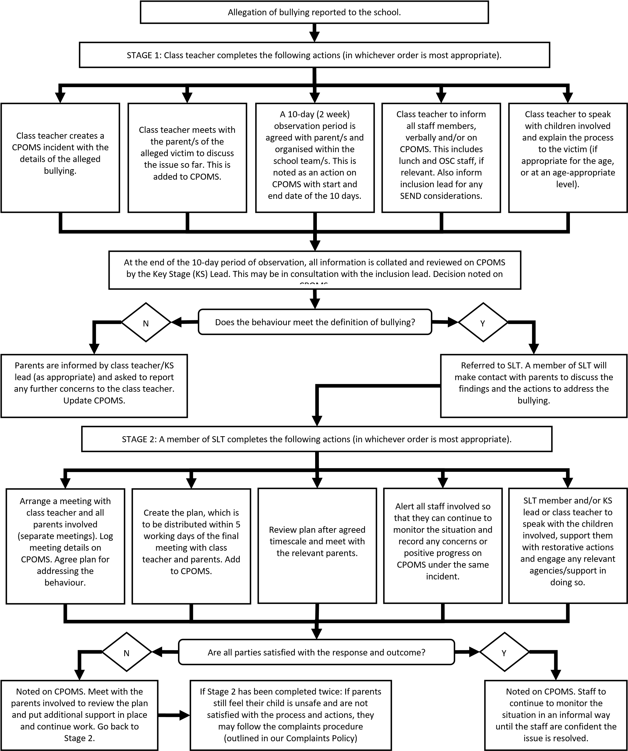

Appendix: Creating plans for anti-bullying
Both parties involved will have work planned as a follow up to the agree incidents of bullying. This will be tailored to the child’s age, needs and understanding.

We will not be using sanctions as a way of ‘punishing’ bullying. This is because we are taking a therapeutic approach to these situations; children are not anti-social for no reason; as previously mentioned, these behaviours are a form of communication.



Key objectives of
the plan

Reported (and agreed) incidents
of bullying

Victim:

•
Rebuild trust with school

•
Ensure safety

•
Explain safety measures

•
Increase 'sense of
safety'

•
Restore and rebuild self-esteem
-

Perpetrator
:

•
Identify/ understand reasons for
behaviour

•
Teach alternative coping strategies
or behaviours

•
Raise self- esteem
-

We will employ the use ‘logical / protective consequence’ language where possible, instead of ‘sanctions’.

Appendix: Cyber/online/electronic bullying
When responding to cyberbullying concerns, the school will endeavour to act in the following ways:
- Act as soon as an incident has been reported or identified- investigating issues and communicating with relevant stakeholders in order to address the bullying
- Encourage the person being bullied to keep any evidence (screenshots) of the bullying activity to assist any investigation.
- Take all available steps where possible to identify the person responsible; this may include the following: o Looking at use of the school systems. o Identifying and interviewing possible witnesses.
- Contacting the service provider and the police, if necessary.
- Following investigation, provide appropriate support for the person who has been cyberbullied and work with the person who has carried out the bullying to ensure that it does not happen again
- Provide information to staff and pupils regarding steps they can take to protect themselves online. This may include the following:
- Advising those targeted not to retaliate or reply
- Providing advice on blocking or removing people from contact lists
- Helping those involved to think carefully about what private information they may have in the public domain.
- Work with the individuals and online service providers to prevent the incident from spreading and assist in removing offensive or upsetting material from circulation. This may include the following:
- Provide reports/information to a service provider to remove content if those involved are unable to be identified or if those involved refuse to or are unable to delete content.
- Requesting the deletion of locally held content and content posted online if they contravene school behavioural policies.
- Ensure that sanctions are applied to the person responsible for the cyberbullying; the school will take steps to change the attitude and behaviour of the bully, as well as ensuring access to any additional help that they may need.

Appendix: Useful links and supporting organisations
The following links and organisations may be helpful:

General
- Anti-Bullying Alliance: www.anti-bullyingalliance.org.uk
- Childline: www.childline.org.uk
- Family Lives: www.familylives.org.uk
- Kidscape: www.kidscape.org.uk
- MindEd: www.minded.org.uk
- NSPCC: www.nspcc.org.uk
- The BIG Award: www.bullyinginterventiongroup.co.uk/index.php
- PSHE Association: www.pshe-association.org.uk
- The Diana Award: www.diana-award.org.uk
- Victim Support: www.victimsupport.org.uk
- Young Minds: www.youngminds.org.uk
- Young Carers: www.youngcarers.net
- The Restorative Justice Council: www.restorativejustice.org.uk/restorative-practice-schools
- National Bullying Helpline: https://www.nationalbullyinghelpline.co.uk/

SEND
- Changing Faces: www.changingfaces.org.uk
- Mencap: www.mencap.org.uk
- SEND code of practice: www.gov.uk/government/publications/send-code-of-practice-0- to-25

Cyber-bullying
- Childnet: www.childnet.com
- Internet Watch Foundation: www.iwf.org.uk
- Think U Know: www.thinkuknow.co.uk
- UK Safer Internet Centre: www.saferinternet.org.uk
- The UK Council for Child Internet Safety (UKCCIS) www.gov.uk/government/groups/uk- council-for-childinternet-safety-ukccis
- DfE ‘Cyberbullying: advice for Headteachers and school staff’:
- www.gov.uk/government/publications/preventing-and-tackling-bullying
- DfE ‘Advice for parents and carers on cyberbullying’:
- www.gov.uk/government/publications/preventing-and-tackling-bullying

Race, Religion, Nationality, Sexuality & Gender
- Anne Frank Trust: www.annefrank.org.uk
- Kick it Out: www.kickitout.org
- Report it: www.report-it.org.uk
- Stop Hate: www.stophateuk.org
- Tell Mama:www.tellmamauk.org
- Educate against Hate: www.educateagainsthate.com

LGBTQ+
- Barnardo’s LGBTQ Hub: www.barnardos.org.uk/what_we_do/our_work/lgbtq.htm
- Metro Charity: www.metrocentreonline.org
- EACH: www.eachaction.org.uk
- Proud Trust: www.theproudtrust.org
- Schools Out: www.schools-out.org.uk
- Stonewall: www.stonewall.org.uk

Sexual harassment and Sexual bullying
- Ending Violence Against Women and Girls (EVAW) www.endviolenceagainstwomen.org.uk
- Disrespect No Body: www.gov.uk/government/publications/disrespect-nobody-campaign-posters
- Anti-bullying Alliance: Preventing and responding to Sexual Bullying: https://anti- bullyingalliance.org.uk/tools-information/all-about-bullying/sexual-and-sexist-bullying
- Anti-bullying Alliance: advice for school staff and professionals about developing effective anti-bullying practice in relation to sexual bullying: www.anti-bullyingalliance.org.uk/tools-information/all-aboutbullying/sexual-and-gender-related ‘

