The St Nicholas Key Code
We show Respect

- Listening when others are talking
- Be polite, please and thank you
- Look after our belongings and those of others
- Treat others how I would like to be treated
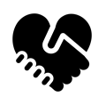

We show Honesty

- by always telling the truth, even when it's difficult
- by taking responsibility for our actions
- by being honest with our peers and teachers
- Share our feelings with a trusted adult when things are hard.

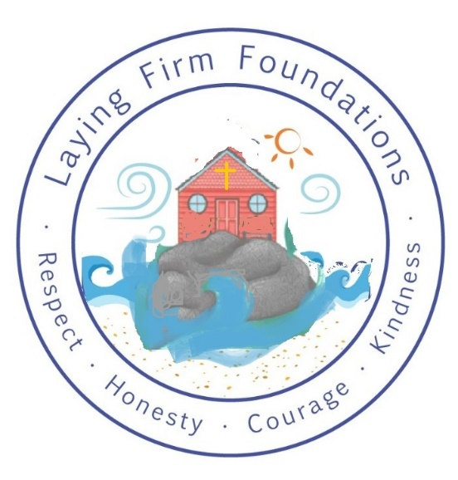

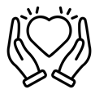
We show Kindness

- by using kind actions and words to all in our school
- by helping and encouraging others to learn
- by listening and participating in lessons
- by showing consideration to ourselves, others, and the environment
- by being willing to show forgiveness


We show Courage

- by standing up for what is right
- by trying new things and taking risks in our learning
- by speaking up and sharing our ideas
- by accepting that we make mistakes

